File Upload Guide
Your homework on this exercise will not be in the Judge system. Instead, you will have to upload a zip file to the SoftUni website.
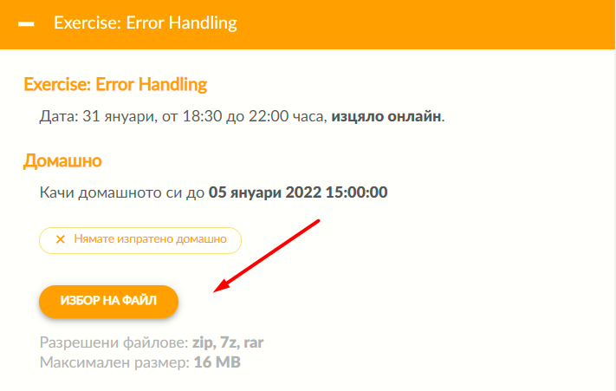
You need to submit your project's folder containing your solutions to the exercise's problems, excluding the .idea and venv folders. If you want to change your solution for some of the problems, you must upload a new zip file. The most recently uploaded solutions will be kept.
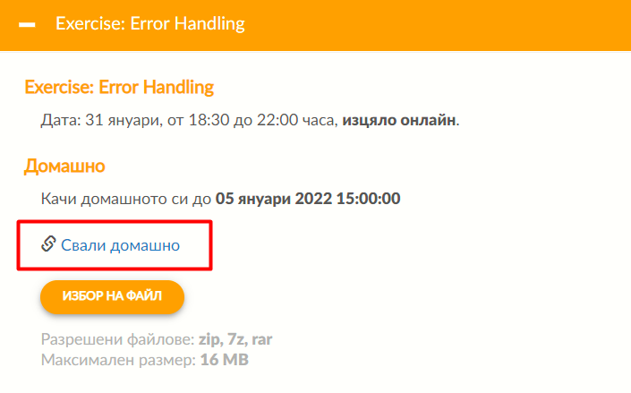
You will have limited time for uploading your homework. If you've successfully uploaded it to the system, you will see the following button from where you can download your homework:
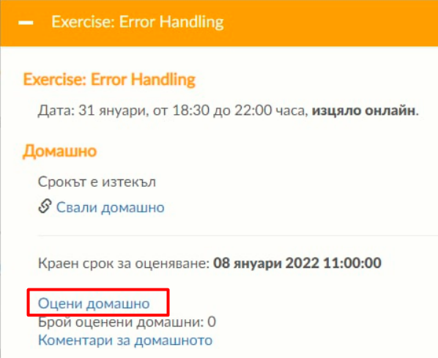
After the homework submission period concludes, a new phase for reviewing and evaluating colleagues' assignments will begin. The results from this assessment will not be included in the final score.

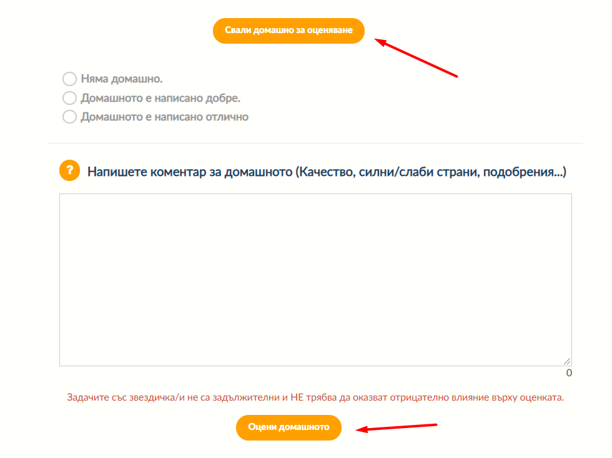
When you click on the button to assess homework, the system will redirect you to a review page. There, you will be able to download a colleague's file, chosen on a random basis. You cannot continue to the next colleague's homework until you assess and review the given one.

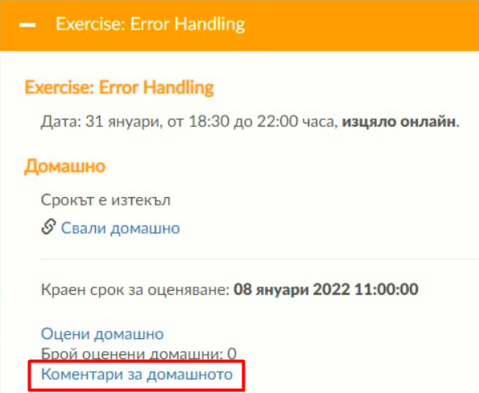
Also, you will be able to see all reviews from your colleagues and assess them as well (correctness and usefulness):

You will be redirected to the following page:


